Architectural Design - 4

PrimeInsurance's pipeline processes files from 6 regional systems daily. During one run, 200 customer records fail validation, some have a missing CustomerID, others have an unrecognized Reg value that does not map to any known region. The business requirement is clear: bad records must not reach analytics, but they must not be lost either.
- The pipeline must continue processing the remaining records without stopping
- Clean records must reach the Silver layer
- Failed records must be preserved separately for the compliance team to investigate
Which Databricks component enables this behaviour, where quality rules are declared as part of the pipeline itself, failed records are automatically separated, and the rest of the pipeline continues uninterrupted? Where does this component sit in your architecture?

Solution -

Delta Live Tables (DLT) with Expectations

DLT Expectations allow you to:
- Define data quality rules declaratively inside the pipeline
- Automatically separate bad records
- Let the pipeline continue processing valid data
- Maintain auditability (critical for compliance)

How it works

Example failures:
- Missing CustomerID
- Invalid Reg (region not in lookup)

In DLT you define rules like:
@dlt.table(
name="silver_customers",
comment="Clean, standardised customer records. Failed records are in silver_customers_quarantine."
)
@dlt.expect_or_drop("customer_id_not_null", "customer_id IS NOT NULL")
@dlt.expect_or_drop("customer_id_positive", "customer_id > 0")

What happens at runtime
Record Type | Outcome
Valid records | Move to Silver table
Invalid records | Sent to quarantine table
Pipeline | Continues without failure

Where do failed records go?
DLT automatically creates:
- Quarantine tables (invalid records)
- Expectation metrics tables (for monitoring)
Example:
silver_customers_quarantine

Flow:
Bronze (Raw Data) —> DLT + Expectations (Validation Layer) —> Silver (Clean Data) + Quarantine Tables (Bad Data)

Why DLT is the right Choice

Requirement | How DLT Solves It
Don’t stop pipeline | Expectations don’t fail pipeline
Clean data to Silver | Valid records flow forward
Preserve bad data | Auto quarantine tables
Auditable | Built-in lineage + metrics
No manual handling | Fully automated

Architectural Design - 5

PrimeInsurance has 14 raw files from 6 regional systems, in CSV and JSON formats, stored across regional sub-folders. These files need to be stored in Databricks in a way that is:
- Cataloged and discoverable - any team member can find what files exist and when they were loaded
- Governed - the compliance team can read Gold layer tables but must not be able to access raw files
- Traceable - for any figure in the final regulatory report, the team can identify exactly which source file it came from
Which Databricks component manages file storage, access control, and data lineage together under one governance layer? How does it fit into your overall architecture?

Solution -

Unity Catalog

Why Unity Catalog is the answer
Unity Catalog is Databricks’ centralized governance layer that manages:
- Data discovery (catalog + schema + tables)
- Access control (fine-grained permissions)
- End-to-end lineage (traceability)

How it solves the problem
Unity Catalog organizes data as:
Catalog → Schema → Tables / Views / Volumes
Anyone can:
- Search datasets
- See metadata (who created, when loaded)
- Understand structure

Governed Access (Critical for Compliance)
You can enforce layer-level security:
Layer | Access
Bronze (raw files) | Restricted (Data Engineers only)
Silver | Limited
Gold | Business + Compliance

Traceability (Lineage)
Unity Catalog automatically captures:
- Source file → Bronze table
- Bronze → Silver → Gold transformations
- Column-level lineage
- Pipeline tracking (DLT integration)

What about raw files (important detail)
Use:

Volumes in Unity Catalog
- Store CSV/JSON files securely
- Govern access at file level
- Still traceable
Example:
/Volumes/primeinsurance/bronze/raw_files/customers.csv

Architectural Design - 6

Every morning, PrimeInsurance's operations team opens its claims dashboard. It must show the current claim rejection rate by region, average claim processing time (the gap between Claim_Logged_On and Claim_Processed_On), and total claim value by incident severity, updated to reflect whatever the pipeline processed overnight. 20 business users access this dashboard simultaneously during morning standups.
Two hard requirements:
- The metrics must refresh automatically when new pipeline data arrives; no engineer should trigger anything manually
- The dashboard must respond quickly, even with 20 users querying at the same time
Which two components in your architecture work together to meet both requirements, one that keeps the aggregated data always current, and one that serves it to business users at speed?
Why must this serving layer be separate from where your pipeline runs?

Solution -
The two components that work together here are:

1. Delta Live Tables (DLT) – Keeps data always current

2. Databricks SQL Warehouse – Serves data fast to users

How they map each other

1. Delta Live Tables
DLT continuously (or on schedule) processes overnight data and builds Gold layer
Key point:
- Runs automatically (scheduled or triggered)
- No manual intervention needed
- Always keeps Gold tables fresh and ready

2. Databricks SQL Warehouse
This is the serving layer used by:
- Dashboards (Power BI / Tableau)
- Business users (20 concurrent users)
Why it works:
- Optimized for low-latency queries
- Handles concurrent users efficiently
- Uses caching + optimized execution engine

Why serving layer MUST be separate from pipeline

If you DON’T separate:
- Pipeline jobs (Spark) and dashboard queries compete for resources
- Morning dashboard = slow / timeout
- Pipeline failures can impact business users
- No workload isolation

With separation:

1. Workload Isolation
- DLT → heavy ETL processing
- SQL Warehouse → lightweight query serving

2. Concurrency Handling
- SQL Warehouse is designed for multiple users
- Pipelines are not

3. Performance Optimization
- Gold tables are pre-aggregated
- SQL Warehouse uses:
  - Caching
  - Photon engine (fast execution)

4. Cost Control
- Scale compute independently:
  - Pipeline → runs once daily
  - Warehouse → runs during business hours

Architectural design - 7
PrimeInsurance's operations and leadership teams need to answer questions like:
- Which policy type (by coverage limit policy_csl) has the highest claim rejection rate?
- What is the average claim processing time by incident severity?
- Which car models are listed for sale but have no sold_on date — and for how long?
Each of these questions cuts across customers, claims, policies, sales, and cars simultaneously.
How will you structure your data to make all of these questions answerable from a single, consistent query? How do they connect?

Solution -
Customer-Centric Star Schema

Fact Tables

1. fact_claims
Grain: One row per claim
- claim_id
- customer_id
- policy_id
- incident_severity
- claim_rejected
- claim_logged_on
- claim_processed_on

2. fact_sales
Grain: One row per vehicle sale/listing
- Sales_id
- car_id
- owner
- Sold_on

Dimension Tables

dim_policy
- Policy_number
- policy_csl

dim_customer
- customer_id
- region

dim_car
- car_id
- model
- Name

Logical Model
dim_customer ───┐
├── fact_claims ─── dim_policy
│
└── fact_sales ─── dim_cars

How each business question is answered

Q1: Highest claim rejection rate by policy type

fact_claims → dim_policy

Q2: Avg claim processing time by severity
From fact_claims directly:

Q3: Unsold cars
fact_sales → dim_cars

Architectural Design - 9

Upload your architecture document. It must include:
- Data flow diagram - end-to-end, from source files to business user
- Component map - every tool or feature used, its layer, and its role
- Data quality strategy - what checks at which layer
- Gen AI integration - where it sits, what goes in, what comes out
Solution -

1. Data Flow Diagram (End-to-End)
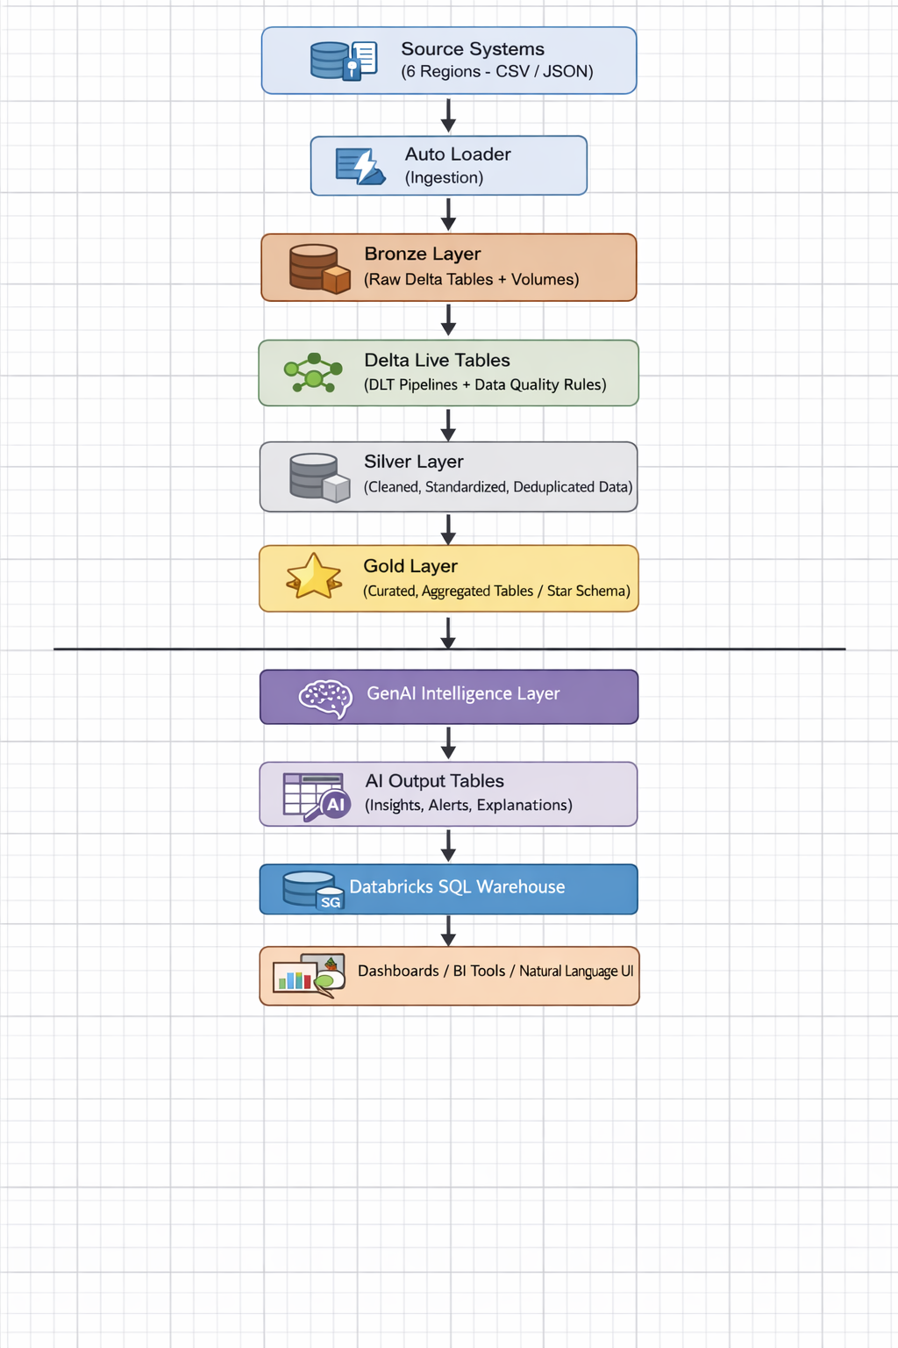

2. Component Map
Component | Layer | Role
Auto Loader | Ingestion | Incremental file ingestion from regional folders
Delta Lake | All Layers | Storage format with ACID transactions and versioning
Unity Catalog | Governance | Data discovery, access control, lineage
Bronze Tables | Bronze | Raw data storage with metadata
Delta Live Tables (DLT) | Pipeline | Data transformation + quality enforcement
Silver Tables | Silver | Cleaned, standardized, deduplicated data
Gold Tables | Gold | Business-ready aggregated and modeled data
Star Schema | Gold | Enables cross-domain analytics
SQL Warehouse | Serving | Fast query engine for dashboards and users
BI Tools (Power BI/Tableau) | Consumption | Business dashboards
GenAI Layer (LLM + Vector Search) | Intelligence | Insights, anomaly detection, NLQ
AI Output Tables | Serving | Stores AI-generated outputs

3. Data Quality Strategy

Bronze Layer (Raw)
- Schema validation
- File format validation
- Basic null checks
Action:
- Log issues only (no pipeline failure)

Silver Layer (Strict Validation)
Checks:
- Missing CustomerID
- Invalid Region values
- Duplicate customers
- Invalid policy references
Actions:
- Valid records → Move to Silver
- Invalid records → Quarantine tables
- Critical failures → Fail pipeline (if required)
Output:
- Clean tables
- Quarantine tables
- Data quality metrics

Gold Layer (Business Rules)
Checks:
- Claim amount vs policy coverage
- Claim rejection anomalies
- Inventory aging thresholds
Actions:
- Warn and alert
- Do not stop pipeline

4. Analytical Data Model (Gold Layer)

Fact Tables
- fact_claims
- fact_sales

Dimension Tables
- dim_customer
- dim_policy
- dim_vehicle
- dim_region

Key Outputs
- customer_360
- claims_summary
- inventory_aging
- Business_unified_view

Architectural Design - 8

Your platform includes a Gen AI intelligence layer built on top of the Gold layer. This layer must: explain data quality issues in plain English to non-technical stakeholders, flag and investigate anomalous claims automatically, and allow business users to ask questions about policies without writing SQL.
Answer the following:
- Which Gold layer table(s) does each Gen AI use case consume, and why does the intelligence layer sit above Gold rather than Silver or Bronze?
- The AI layer produces outputs (explanations, investigation briefs, query answers). Where do these outputs live in your architecture, and how are they made available to business users?
- PrimeInsurance's analysts want to ask questions like "show me all Premium policies in Ohio" directly in the analytics UI, without code. Which Databricks feature enables this, and what does it require from the Gold layer to work well?

Solution -

Gen AI Intelligence Layer — Design Explanation

Which Gold Tables Each Use Case Consumes

A. Data Quality Explanation (DQ AI)
Consumes:
- primeins.gold.dq_issues
- primeins.gold.quality_issue_log
Why:
- dq_issues contains failed records, rule names, columns, and error context
- Gold layer ensures:
  - Clean schema
  - Standardized rule outputs
  - Business-friendly column names

B. Anomaly Detection & Claim Investigation
Consumes:
- primeins.gold.fact_claims
- primeins.gold.dim_policy
- primeins.gold.dim_customer
Why:
- fact_claims → claim amounts, dates, statuses
- dim_policy → coverage limits, deductible, risk profile
- dim_customer → demographics, fraud signals
AI correlates:
- Claim vs coverage
- Claim frequency vs normal patterns
Output example:
“Claim amount exceeds policy limit by 35%. Customer has 5 claims in 2 months — anomaly detected.”

C. Policy Q&A (RAG System)
Consumes:
- primeins.gold.dim_policy
Why:
- This is the source of truth for policy attributes
- Structured → converted into documents for semantic search
Used for:
- Deductibles
- Coverage tiers
- Umbrella coverage
- Policy limits
Why Gen AI Layer Sits Above Gold (NOT Silver/Bronze)

Gold Layer Characteristics:
- Cleaned
- Conformed dimensions
- Business-ready
- Trusted metrics

Why NOT Bronze:
- Raw, unvalidated data
- Schema inconsistencies
- High noise → hallucination risk

Why NOT Silver:
- Still partially transformed
- Not fully business-contextualized
- May contain intermediate logic

Why Gold:
- Single source of truth
- Joins already resolved
- Metrics aligned with business definitions

Where AI Outputs Live + How Users Access Them

Output Tables (Gold Layer Extension)
Use Case | Output Table
DQ Explanation | primeins.gold.dq_explanation_report
Anomaly Detection | primeins.gold.claim_anomaly_report
RAG Q&A Logs | primeins.gold.rag_query_history

How Business Users Access This

1. Databricks SQL Dashboards
- Visualize anomalies
- Track DQ trends
- View explanations

2. Genie (Natural Language UI)
- Ask questions directly

3. BI Tools (Power BI / Tableau)
- Connected to Gold tables

Natural Language Queries (No SQL)

Databricks Genie

What It Does
Enables users to ask:
“Show me all Premium policies in Ohio”
Converts → SQL → Executes → Returns result

What Genie Requires from Gold Layer

1. Clean Schema
- No ambiguous column names
- Example:
  - policy_state (good)
  - NOT st_cd (bad)

2. Well-Defined Relationships
- Proper joins:
  - fact_claims.policy_id = dim_policy.policy_id

3. Business-Friendly Naming
- coverage_tier instead of cov_lvl_cd

Architecture Summary
Bronze → Raw ingestion
↓
Silver → Clean + validated
↓
Gold → Business-ready tables
↓
Gen AI Layer
├── DQ Explanation AI
├── Anomaly Detection AI
├── RAG Policy Assistant
↓
Gold Output Tables (AI Results)
↓
Consumption
├── Databricks SQL
├── Genie (NLQ)
├── Dashboards

